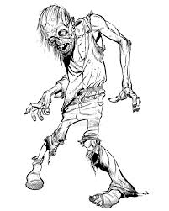
Zombie Scavenger Hunt

Friday October 28

Registration: 6:30 – Grades 7, 8 & 9
7:00 – 8:00 Grades 9, 10 & 11
8:30 – SENIORS

Cost is $7 or $5 with a non-perishable food item

